**Practical No. 10: Write a program to demonstrate status of key on Applet window such as KeyPressed, KeyReleased, KeyUp, KeyDown.**

**Exercise:**

**3. Develop a program to accept two numbers and display product of two numbers when user pressed “Multiply” button.**

**Program:**

import java.awt.*; import java.awt.event.*;

import javax.swing.*;

import java.applet.*;

public class pract10_ex3 extends JApplet implements ActionListener

 { JTextField jtf1,jtf2,jtf3;

JButton jb; JLabel jl1,jl2,jl3;

public void init() {

Container c = getContentPane();

c.setLayout(new GridLayout(4,2));

jtf1 = new JTextField();

jtf2 = new JTextField();

jtf3 = new JTextField();

jb = new JButton("Multiply");

 jl1 = new JLabel("Number 1",JLabel.CENTER);

jl2 = new JLabel("Number 2",JLabel.CENTER);

jl3 = new JLabel("Answer",JLabel.CENTER);

jb.addActionListener(this);

c.add(jl1);

 c.add(jtf1);

c.add(jl2);

c.add(jtf2);

c.add(jl3);

c.add(jtf3);

c.add(jb);

}

public void actionPerformed(ActionEvent ae)

{

String s1 = jtf1.getText();

String s2 = jtf2.getText();

int i1 = Integer.parseInt(s1);

int i2 = Integer.parseInt(s2);

int mult = i1*i2;

String ans = Integer.toString(mult);

jtf3.setText(ans);

repaint(); } }

/* <applet code=pract10_ex3.class width=400 height=400>

 </applet>

*/

**Output:**

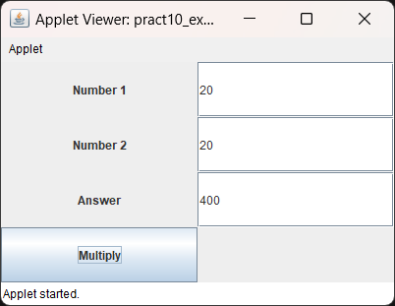

**Program Code:**

1. **Write a program to generate KeyEvent when a key is pressed and display “KeyPressed” message.**

**Program:**

**Code:**

import java.awt.*;

import java.awt.event.*;

public class pract10_X1 extends Frame implements KeyListener

{

Label l;

TextArea ta;

pract10_X1 ()

{

setSize(400,400);

setLayout(null);

setVisible(true);

l = new Label();

l.setBounds(20,50,100,20);

ta = new TextArea();

ta.setBounds(20,80,300,300);

ta.addKeyListener(this);

add(l);

add(ta);

}

public void keyPressed(KeyEvent ke)

{

l.setText("Key Pressed");

}

public void keyReleased(KeyEvent ke)

{

}

public void keyTyped(KeyEvent ke)

{

}

public static void main(String[] args)

{

new pract10_X1();

}

}/*

<applet code=pract10_X1.class width=300 height=300>

</applet>

*/

**Output:**

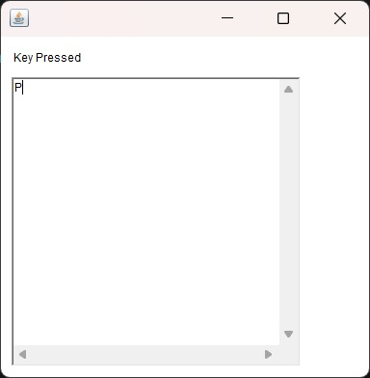

1. **Develop Program which will implement special keys such as function keys and arrow keys.**

**Program:**

import javax.swing.*;

import java.awt.*;

import java.awt.event.KeyEvent;

import java.awt.event.KeyListener;

public class pract10_X2

{

public static void main(String[] args)

{

JFrame frame = new JFrame("Special Keys Program"); frame.setDefaultCloseOperation(JFrame.EXIT_ON_CLOSE);

frame.setLayout(new FlowLayout());

JLabel label = new JLabel("Press a special key...");

frame.add(label);

frame.addKeyListener(new KeyListener()

{

public void keyTyped(KeyEvent e)

{

}

public void keyPressed(KeyEvent e)

{

int keyCode = e.getKeyCode();

if (keyCode >= KeyEvent.VK_F1 && keyCode <= KeyEvent.VK_F12)

{

label.setText("Function key pressed: F" + (keyCode - KeyEvent.VK_F1 + 1));

}

else if (keyCode == KeyEvent.VK_UP)

{

label.setText("Up arrow key pressed");

}

else if (keyCode == KeyEvent.VK_DOWN)

{label.setText("Down arrow key pressed");}

else if (keyCode == KeyEvent.VK_LEFT)

{label.setText("Left arrow key pressed");}

else if (keyCode == KeyEvent.VK_RIGHT)

{label.setText("Right arrow key pressed");}}

public void keyReleased(KeyEvent e)

{}});

frame.setSize(300, 100);

frame.setVisible(true);}}

**Output:**

